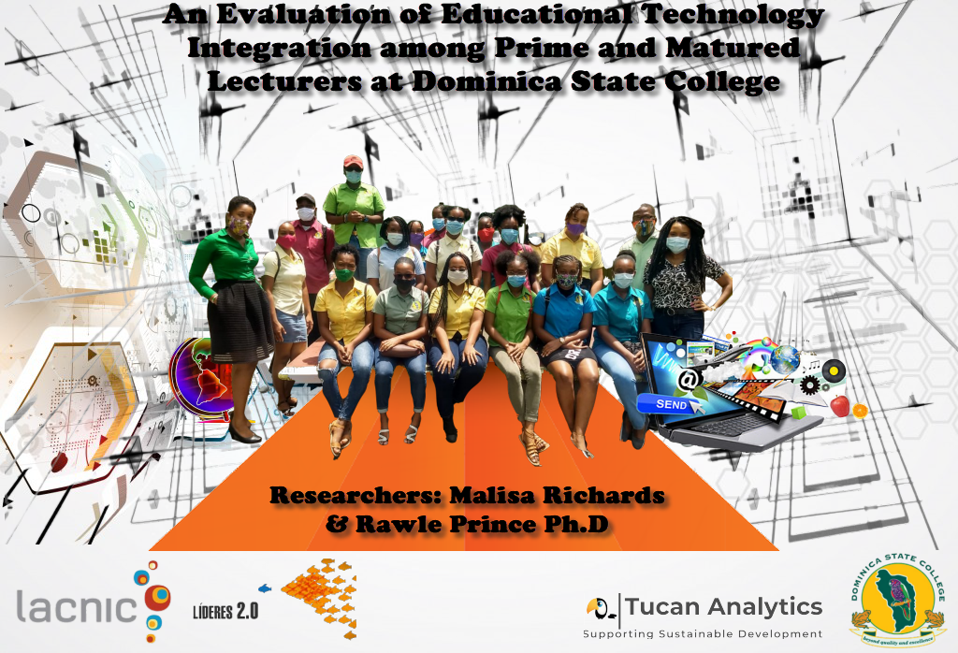

2021
FINAL REPORT
An Evaluation of Educational Technologies Integration among Prime and Matured Lecturers at Dominica State College.
This research was funded by the Latin American and Caribbean Internet Addresses Registry (LACNIC) under the Internet Governance theme of the Lideres 2.0 program and was authored by Malisa Richards and Rawle Prince.
This report presents the authors’ best attempt to evaluate educational technologies at Dominica State College based on surveys, interviews, and desk research. The completeness of the information presented in the report constitutes a first with respect to prime and matured lecturers utilising educational technologies. The authors are grateful for the support received from LACNIC and the institutional support received from Dominica State College that enabled this report to be produced.
The opinions expressed and arguments employed herein are those of the authors and do not necessarily reflect the official views of Latin American and Caribbean Internet Addresses Registry (LACNIC).

© 2021 LACNIC Lideres 2.0
Research Mentor: Mr. Nigel Cassimire
Faculty Advisor: Dr. Hermancia Zamore Ph.D

This report is designed to serve as a resource to LACNIC, Dominica State College in the Commonwealth of Dominica and the Organisation of Eastern Caribbean States who from time-to-time conduct research and/or implement projects related to educational technology. The content of this report is available for use in all proposals designed to improve how educational technology is evaluated and serve as a basis for future research in the region.
This publication should be cited as: Latin American and Caribbean Internet Addresses Registry (LACNIC) Lideres 2.0, Internet Governance, An Evaluation of Educational Technologies Integration among Prime and Matured Lecturers at Dominica State College December 2021, Roseau, 2021

About the Researchers

Malisa Richards MSc

Computer Science Lecturer, Dominica State College. Ms. Richards attained her master’s degree in Information Systems and Technology Management from the University of the West Indies, St. Augustine Campus, and her bachelor’s degree in Statistics from the University of Guyana. She also obtained a diploma/associate degree in Computer Science from the University of Guyana.
Her involvement with internet governance witnessed her being a fellow for Internet Corporation for Assigned Names and Numbers (ICANN), Internet Society (ISOC), American Internet Registry (ARIN), and the Latin American and Caribbean Internet Addresses Registry (LACNIC). The Internet Society Guyana Chapter, whom she is the founder resulted from her commitment at ICANN 58.

Rawle C.S. Prince Ph.D.

Director and founder of Toucan Analytics in the United Kingdom. Mr. Prince attained his doctorate in Computer Science from the University of Nottingham and his master’s degree in Artificial Intelligence from University of Edinburgh.
A quantitative analyst with extensive experience delivering non-trivial projects in both academic and commercial settings. These have led to key outcomes, including the development of new techniques for optimizing search and deterioration modelling in infrastructure asset management and the development of a robust framework for simultaneously calibrating numerous deterrence functions in trip distribution modelling. Mr. Prince is currently working on several ground-breaking projects involving the use of location data, primarily from mobile phones, to derive mobility intelligence, retrospectively as well as in real time.

Acknowledgement

This research would not have been possible without the financial support of Latin American and Caribbean Internet Addresses Registry (LACNIC). The researchers sincerely thank LACNIC Lideres 2.0 team for the selection of their application, which made this research possible. The researchers are especially grateful for the guidance and input received from Mr. Nigel Cassimire, LACNIC Lideres 2.0 Mentor. Mr. Cassimire has certainly taught the researchers more than we could ever credit him for. He has clearly demonstrated what is means to be a good mentor.
Partners of this report are (LACNIC), Dominica State College, and Tucan Analytics. This report is supported under the Internet Governance theme of LACNIC Lideres 2.0 in September 2021 and implemented by Malisa Richards of Dominica State College and Mr. Rawle Prince Ph.D. of Tucan Analytics.
The report was led and managed by Ms. Malisa Richards, Computer Science Lecturer, Dominica State College with the approval of Dominica State College’s Internal Review Board (IRB). Extensive support was also received from Dr. Hermancia Eugene-Zamore Ph.D., Dean, Academic Affairs, Dominica State College. The researchers sincerely thank the Internal Review Board, Dean of Academic affairs, lecturers and students for their support and participation in the research to make it a success.
The production of this report was coordinated by the researchers, Mr. Nigel Cassimire and LACNIC Lideres team. The content of the report was enriched by constructive feedback received from Mr. Nigel Cassimire and the LACNIC Lideres team.

Acronyms and Abbreviations

ASSURE Analyse, State objectives, Select design materials, Utilise materials, Require
learner response and Evaluate
CFT Competency Framework for Teachers
CS Continuing Studies Division
DSC Dominica State College
DSL Digital Subscriber Line
EC Eastern Caribbean
EdTech Educational Technology
eLearning Electronic Learning
eLSe eLearning for Seniors
FAS Faculty of Arts and Science
FAAT Faculty of Arts and Applied Technology
FHS Faculty of Health Science
FOE Faculty of Education
GS General Studies Division
ICT Information and Communications Technology
IDB Inter-American Development Bank
IRB Internal Review Board
ITU International Telecommunication Union
LAC Latin America and the Caribbean
LACNIC Latin American and Caribbean Internet Addresses Registry
LMS Learning Management System
NGO Non-Governmental Organisation
NTRC National Telecommunication Regulatory Commission
SAMR Substitution, Augmentation, Modification, and Redefinition
TPACK Technological Pedagogical Content Knowledge
UN United Nations
UNESCO United Nations Educational, Scientific and Cultural Organization
UN SDG United Nations Sustainable Development Goals
WEF World Economic Forum

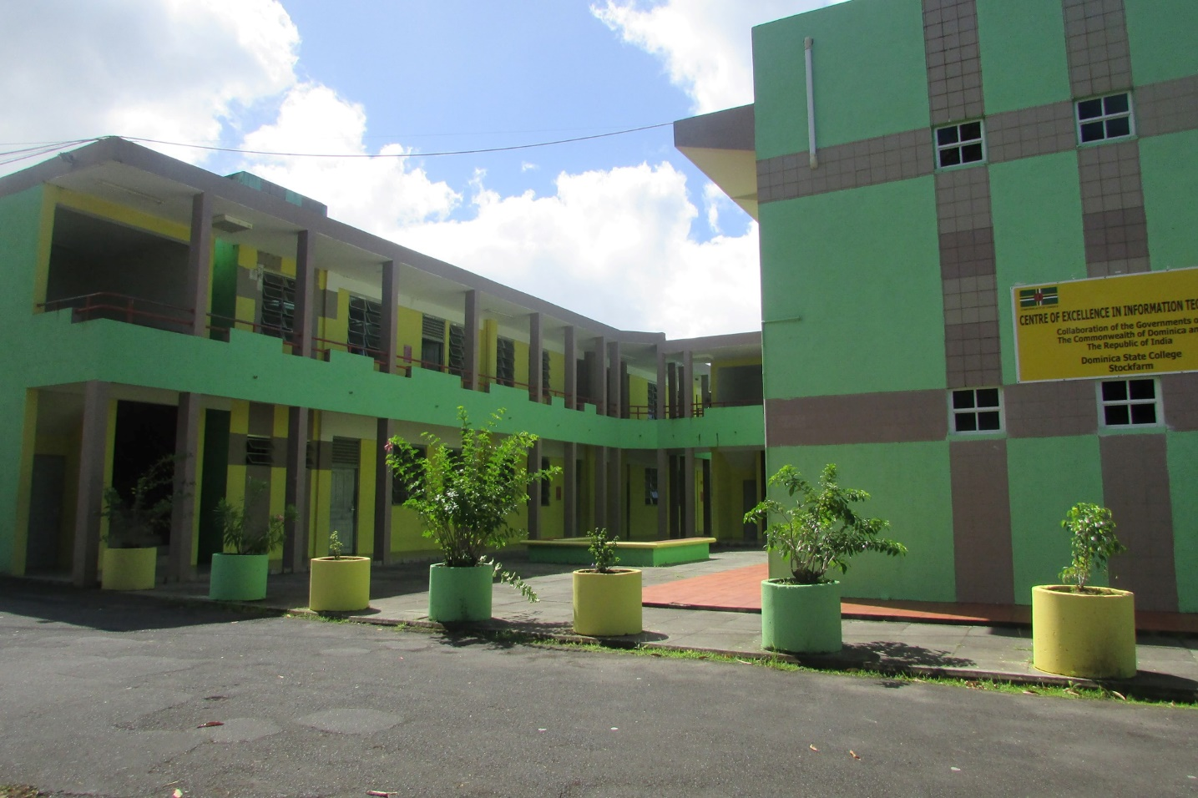
Dominica State College

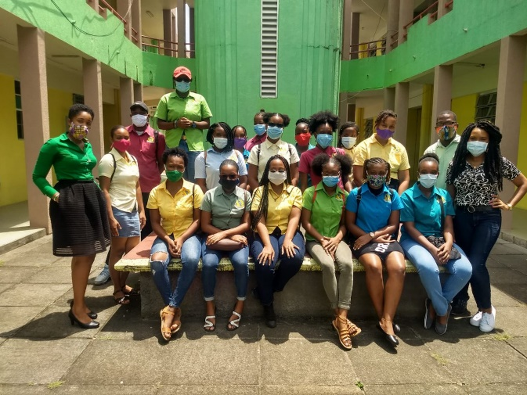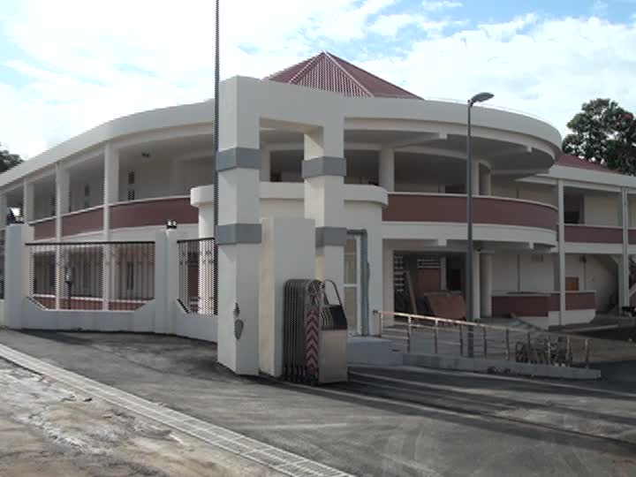

Overview of Dominica State College

Background of Dominica State College
Dominica State College is a public tertiary institution in the Commonwealth of Dominica. The college was renamed Dominica State College in September 2002. The college is governed by a fourteen (14) member Board of Governors. The Board of Governors are responsible for the appointment of academic staff and adjunct members. There are fifty-five (55) full-time academic staff and eighteen (18) adjunct members. The main functions of the college are developing courses specific to community needs; promote and disseminate knowledge in areas relevant to government, private sector, and civil society; and conferring of degrees and granting of certificates, diplomas, and relevant awards.

Mission Statement
The mission of the college is “to become the premiere institution by delivering high-quality accessible academic programs, meeting the needs of the various communities and businesses, while facilitating personal and professional development.”

Vision
The revised vision of the college is “to be a student-centered, dynamic, and innovative, world-class multi-campus college.”
The college strives to:
- Promoting excellence in lecturing and learning
- Serving diverse communities
- Producing lifelong learners who can complete globally

Educational Technology at Dominica State College
The Orbund Student Information System is the main electronic learning (eLearning) platform utilized by Dominica State College. This platform has been in use for approximately fifteen years. It provides students with access to announcements, courses, exam schedules, submission of assignments, viewing of coursework assignments, coursework grades, final grades attendance, and messaging between students and faculty members. Conversely, lecturers view lecturing and exam schedules; update student attendance and grades; import assessments and resources from previous courses taught; messaging between faculty members and students; access to an online repository; equipment reservation system; academic advisor referral, counsellor referral, student exemption system and events calendar.
During academic year 2021-2022, considering the pandemic, the college invested in Zoom classrooms due to the increase in COVID-19 cases across the island, all classes were conducted via Zoom web conferencing platform. As an alternative, Google meet was also utilized.

Industry
Dominica State College competes against internationally accredited universities such as University of the West Indies, All Saints Medical University, International University for Graduate Studies, Munroe College, among others. The higher education sector is extremely competitive; however, Dominica State College’s offers tuition-free programmes to their nationals.

Table of Chapters
About the Researchers 2
Malisa Richards MSc 2
Rawle C.S. Prince Ph.D. 2
Acknowledgement 3
Acronyms and Abbreviations 4
Overview of Dominica State College 7
Background of Dominica State College 7
Mission Statement 7
Vision 7
Educational Technology at Dominica State College 7
Industry 7
Abstract 12
Chapter 1.0 Executive Summary 13
Respondent Overview 13
Findings 13
Use of Educational Technology and Ease of Transition 13
Use of Educational Technology by Faculty 14
Type of Broadband Available and Quality of Delivery 14
Recommendations 15
Educational Technology Integration at Dominica State College 15
Educational Technologies Competencies and Skills 15
Chapter 2.0 Introduction 16
Chapter 3.0 Problem Overview 17
3.1 Problem Statement 17
3.2 Research Objectives 17
3.3 Research Question 17
Chapter 4.0 Literature Review 18
4.1 Prime and Matured Lecturers 18
4.2 Education Technology adoption among Prime and Matured Lecturers 18
4.3 Technology Adoption across the various continents 18
4.3.1 Technology adoption in Asia 18
4.3.2 Technology adoption in Africa 18
4.3.3 Technology adoption in Latin America and the Caribbean 19
4.4 Frameworks used when adopting Educational Technologies in the Classroom 19
4.5 The Role of Pedagogy in Educational Technology Adoption 19
Chapter 5.0 Methodology 21
5.1 Participants 21
5.2 Population 21
5.3 Design 21
5.4 Data Collection 21
5.5 Efficacy Index 22
5.6 Ethical Considerations 23
Chapter 6.0 Demographic Profile of Lecturers 24
6.1 Demographic Profile - Prime and Matured Lecturers 24
6. 2 Employment Status - Prime and Matured Lecturers 25
Chapter 7.0 Demographic Profile of Students 26
Chapter 8.0 Findings 28
8.1 Use of Educational Technology and Ease of Transition 28
8.2 Use of Educational Technology by Faculty 30
8.2.1 Technological Knowledge 31
8.2.2 Pedagogical Knowledge 33
8.3 Type of Broadband Available and Quality of Delivery 34
8.4 Delivery Methods 35
8.5 Assessment of Dependency Factors 38
8.6 Online Efficacy 39
Chapter 9.0 Recommendations 42
9.1 Educational Technology Integration at Dominica State College 42
9.2 Educational Technologies Competencies and Skills 45
Chapter 10.0 Conclusion 46
Chapter 11.0 Future Research Implications 47
Chapter 12.0 References 48
Chapter 13.0 Annex 51
Annex A – Tabular Details of Prime and Matured Respondents 51
Annex B - Tabular Details of Students 53
Annex C – APPLICATION OF BALANCED SCORECARD FOR DSC 55
Annex D – UNESCO ICT COMPETENCY FRAMEWORK FOR TEACHERS 58

List of Tables
Table 1- Question used to derive an efficacy index for lectures 22
Table 2- Student computer experience compared with rating of ease of transition with Zoom App 29
Table 3- Faculty breakdown of student's response to integrating of educational technologies 33
Table 5- Sex and Age Range of Prime and Matured Respondents 51
Table 6- Sex, Age Range and Qualification of Prime and Matured Respondents 51
Table 7- Sex breakdown of qualifications attained by Prime and Matured Respondents 51
Table 8- Prime and Matured Lecturers Faculty, Department and Years Employed 52
Table 9 - Faculty and Lecturers' integration 52
Table 10- Breakdown of Students by Age range, faculty, and sex 53
Table 11- Distribution of Age Range and Sex of Students 54
Table 12- Faculty breakdown by Sex 54
List of Figures
Figure 2- Sex, Age Range and Qualification of Prime and Matured Lecturers 24
Figure 3- Faculty and Teaching Experience of Prime and Matured Lecturers 25
Figure 4- Students’ Age Range broken down by Sex 26
Figure 5- Students’ Faculty broken down by Age Range 27
Figure 6. Educational Technologies used 28
Figure 7. Ease of transition to online learning 30
Figure 8. Use of Educational Technologies by faculty 31
Figure 9 - Prime and Matured Lecturer's Frequent use of Educational Technology 32
Figure 10. Impact of broadband type on attendance 34
Figure 11. Network technology used to deliver online content 35
Figure 12. Online delivery methods by broadband types 36
Figure 13 - Type of broadband accessed by students 37
Figure 14. Online fatigue by workload classification. 38
Figure 15. Transition effort and impact on workload 39
Figure 16. Efficiency and ease of transition to online learning 40
Figure 17. Efficacy by Attendance 40
Figure 18- EdTech Integration at Dominica State College 42
Figure 19 - The four dialecticals 43
Figure 20 - Balanced Scorecard applied to Higher Education 55
Figure 21 - Balanced Scorecard Strategy Map 56
Figure 22 - Balanced Scorecard for Reporting 57
Figure 23 - The 18 competencies organized according to the six aspects of lecturers' and three levels 58
Figure 24 - Level 1 Goals 58
Figure 25 - Level 2 Goals 59
Figure 26 - Level 3 Goals 59
Figure 27 - Level 1 Competencies 60

Abstract
This research reports on the factors influencing educational technology integration and the impact of these factors among prime and matured lecturers at the Dominica State College. Three sets of questionnaires were administered via Google Forms to lecturers and students and one specifically for lecturers deemed to be 40 years and older (i.e., prime and matured).
A total of 491 students participated in the students survey, while there were 11 respondents deemed as prime and matured lecturers and 33 respondents for the general survey.
The study found that both lecturers and students easily transitioned to online learning while incorporating educational technologies into their lecturing activities. The study also found that on average, a household using both fixed broadband and mobile data spent approximately US $57 per month. Faculty of Arts and Science lecturers significantly utilised educational technologies in their lecturing activities compared to the other faculties.

Keywords: EdTech, Educational Technology, EdTech Evaluation, Prime and Matured EdTech Integration
Executive Summary

Executive Summary

The COVID-19 pandemic did not transform educational technologies in higher education, instead it fast-tracked and further highlighted issues that were not seemingly prevalent. The nature of this digital age naturally inherits technological challenges that higher institutions grapple with Dominica State College included. Accompanying our digital age, are digital users at Dominica State College particularly lecturers and students connected via broadband and mobile data. Lecturers incorporate educational technologies into their lectures to improve and enhance the educational content disseminated to students. This research mainly focused on Prime and matured lecturers at Dominica State College. Prime and matured lecturers was defined by Dominica’s age structure as individuals between the chronological age of 25-54 years (the prime working age) and 55-64 years as the mature working age (Index Mundi 2021).

Respondent Overview
The Prime and matured lecturers’ survey. overall, a total of 11 lecturers participated. The sex composition of respondents were 6 females and 5 males. The median age range was determined to be 40-49. The majority of the lecturers i.e., 7, were associated with Faculty of Arts and Sciences (FAS), 3 from Faculty of Education (FOE), and 1 from General Studies (GS) Division. 5 of the respondents were employed 16 years or more with the college, while 2 were employed 11 – 15 years, another 2 were employed 6 – 10 years and 2 employed 0-5 years.
In relation to students’ survey, overall, a total of 491 students participated. The sex composition of students revealed that 392 were females and 99 were males. The median age range of the students was the 15 – 20 while the mean age was 19 years. Overall, Faculty of Arts and Science (FAS) recorded a total of 331 students (55 males and 276 females), Faculty of Arts and Applied Technology (FAAT) recorded 60 students (34 males and 26 females), General Studies 42 students (1 male and 2 females), Faculty of Health Science (FHS) recorded 48 students (4 males and 38 females), while Faculty of Education (FOE) recorded 13 students (1 male and 12 females), and Continuing Studies recorded 3 students (1 male and 2 females).

Findings

Use of Educational Technology and Ease of Transition
The most popular educational technology used was Zoom, the survey suggested that 93% of the lecturers utilised this platform. Approximately 50% of lecturers used technologies from Google Educational Suite (i.e., Google Meet or Google Classroom), while a mere 33% use WhatsApp in their lessons. A further 7% indicated use of other technologies such as Kaizala and Microsoft Teams.
The vast majority of lectures i.e., 92%, agreed that it was ease fairly easy to transition to educational technologies, while a mere tiny minority of lecturers i.e., 8%, claimed to have experienced some difficulties during the transition phase.

Use of Educational Technology by Faculty
Overall, Faculty of Arts and Science (FAS) respondents used Orbund (20%) platform with Zoom (28%) and Google Classroom (14%), Google Meet (5%), WhatsApp (11%) and other (2%) (Kaizala and Microsoft Teams) most frequently compared to the other faculties. There was a significant difference between Faculty of Arts and Science when compared with the other faculties. Specifically, for Orbund, Zoom, Google Classroom, Google Meet, WhatsApp and other educational technologies, the maximum percentage was 5% across Faculty of Education (FOE), Faculty of Health Sciences (FHS), Faculty of Arts and Applied Technology (FAAT), and General Studies. Faculty of Arts and Science integrated educational technology most frequently in comparison to the other faculties.
The students’ survey determined a high percentage of lecturers integrated educational technologies in their lectures. Comparatively, Faculty of Education and General Studies Division least integrated educational technologies in their lectures. The data also suggests that there’s a significant difference between educational technology integration in Faculty of Arts and Science and the other faculties.

Type of Broadband Available and Quality of Delivery
Overall lecturers reported high attendance to classes with 65% reporting an attendance rate of 91-100%. Among this 65%, 26% lecturers used DSL to deliver their online content, 23% used mobile data and 16% used high-speed fibre. Of the remaining 35% of lecturers, 27% reported an attendance rate of 81-90% to their online classes of which 15% use mobile data and 12 use high-speed fibre.
Single broadband use determined 36% of students used high-speed fiber, 17% other, 16% DSL, and 11% mobile data. However, it was determined that the students used a combination of connection types to attend online classes. Mobile data and high-speed fibre (4%) were the most frequently used combination while Mobile data, DSL and other were the least frequently used (0.2%).

Recommendations

Educational Technology Integration at Dominica State College

Dominica State College can be considered a higher education institution transitioning from emergency mode to continuity mode. A large proportion of lecturers claimed they did not experience online fatigue and that the shift to online delivery had a moderate impact on their workload. Thus, the survey data suggest that lecturers are coping well with the workload despite having to make some adjustments to adopt to online delivery. As the college moves forward, the hybrid approach must certainly consider four dialecticals, namely, instruction that blends technological, temporal, spatial, and pedagogical dimensions to create actualized learning.

Educational Technologies Competencies and Skills
The UNESCO Information and Communication Technology Competency Framework for Teachers (ICT CFT) version 3 (UNESCO 2019) encourage lecturers to integrate educational technologies into their synchronous and asynchronous classes. This integration is supported via 18 educational technology-related competencies, classed into three levels and each with six aspects. The three levels are Level 1 - Knowledge Acquisition, Level 2 – Knowledge Deepening, and Level 3 - Knowledge Creation. The six aspects are understanding educational technology in education policy; curriculum and assessment; pedagogy; application of digital skills; organization and administration; and teacher professional learning.

Introduction

Introduction

The Global EdTech Market Report, 2021 edition valued the EdTech industry at US$85 billion identifying the drivers of market growth as spiraling exigencies for digital learning and aggressive investments in EdTech. 2021 – 2030 was formally declared “the Decade of Healthy Aging” by the United Nations. This declaration endorsed the mobilization of multistakeholder from all sectors of society to collaboratively prioritize the aging population. According to ITU’s publication Aging in a Digital World, “the world is digital, and society is aging.” The World Economic Forum endorsed the United Nations multistakeholder approach to aging positing enterprises such as civil society, policymakers, and academia ought to pool resources to establish a unified platform.
The COVID-19 pandemic significantly disrupted sectors globally and according to the October 2021 editorial on Tackling the Digital Divide published in the Lancet Healthy Longevity “one of the most striking, especially where movement outside home was legally prohibited or curtailed, was the unequal access to and use of digital technologies.” This unequal access was in the case of students at the Dominica State College, can be expanded to broadband connectivity, where the college conducted a study during academic year 2020 - 2021 revealing that more than 20% of its students did not have access to broadband internet connection at home. The legal prohibition restricted large gatherings which includes face-to-face classes conducted by colleges and universities thus forcing these higher education institutions to expeditiously conform to the new technological demands while rapidly deploying an assortment of educational technologies. The rapid deployment of the assortment of educational technologies introduced additional threats directly affecting lecturers. Without any notice lecturers were required to immediately transition and demonstrate technologically versatile skills in their lecturing activities to maximizing student learning while students on the other hand, had no choice but to immediately adapt to the new way of learning.
This research evaluated educational technology integration among prime and matured lecturers at Dominica State College aimed at identifying educational technology factors and its impact. The intended outcome of this research was to produce an evaluation report of the current educational technologies utilised by prime and matured lecturers at the college.
This report provides an overview of the research conducted at Dominica State College during October 1, 2021, to November 22, 2021.

Problem Overview

The occurrence of the COVID-19 pandemic in 2020, required that the college immediately implement transition to online learning, requiring lecturers to utilise various web conferencing tools such as Zoom and Google Meet for live classroom sessions. The country’s spike in COVID-19 rates required that the college once again transition to online learning for semester one during academic year 2021-2022. With the spike in COVID-19 cases across the country and the lessons learned from academic year 2020-2021, the college invested in Zoom classrooms to facilitate this transition.
The occurrence of the Covid-19 pandemic forcibly highlighted key neglected areas within the realm of educational technology integration in higher education. One such area was lecturer’s ability to integrate educational technology into their online delivery. Technology integration during natural disaster is not exempted from its own challenges. Some of the challenges encountered by higher education institutions are inconsistent integration approaches, delivery approach is not structured, and planning is lacking thus hindering business continuity (McDonald 2019).
(Martínez-Alcalá, et al. 2018) postulates that many higher education institutions have taken initiative in addressing this need. To address the needs of lecturers, many researchers such as (Arenas 2015) & (Shohel and Kirkwood 2012) addressed the psychological and social contexts positing socio-cultural, politics, economic, leadership, attitude, competency, and skills are critical factors that must be successfully navigated. These are critical since they directly impact educational technology integration in lecturing and learning activities.

3.1 Problem Statement
How can Dominica State college improve educational technology integration among prime and matured lecturers? What are the factors influencing the integration process?

3.2 Research Objectives
The objectives of the research are:
- To identify the factors influencing educational technology integration
- To evaluate the impact of these factors among prime and matured lecturers

3.3 Research Question
The research addressed the following:
- What are the factors influencing educational technology integration among aging lecturers?
- How do these factors impact the expectations of aging lecturers in their online delivery?

Literature Review

4.1 Prime and Matured Lecturers
According to ITU’s publication Aging in a Digital World, “the world is digital, and society is aging.” Latin America and the Caribbean was identified as the fastest aging region during the launch of IDB’s Silver Economy Innovation Challenge. The region’s demographic transition varies as some member states are avant-garde while others are transitioning (World Bank 2021) as published in a World Bank blog. This demographic transition certainly does not exclude higher education’s prime and matured lecturers. Prime and matured lecturers can be defined according to Dominica’s age structure as individuals between the chronological age of 25-54 years (the prime working age) and 55-64 years as the mature working age (Index Mundi 2021).

4.2 Education Technology adoption among Prime and Matured Lecturers
(Mitzner 2010) postulates the positive attitude of prime and matured lecturers supersedes negative perspectives associated with technology adoption. However, there is a lack of consensus regarding prime and matured lecturers' technological opinions. (Demiris, et al. 2004); (Heinz, et al. 2013); (McMellon and Schiffman 2002) reported various findings in this regard alluding that some lecturers are very much accepting regarding technology adoption. Conversely, (Morrell, Mayhorn and Bennett 2000) contradicts (Demiris, et al. 2004); (Heinz, et al. 2013); (McMellon and Schiffman 2002) positing that some matured lecturers are very much resistant to technological adoption. There is a lack of research that seeks to understand the underlying reasons behind such viewpoints.

4.3 Technology Adoption across the various continents
Technology adoption process across Asia, Africa and the Latin America and Caribbean region will be reviewed.

4.3.1 Technology adoption in Asia
The continent of Asia combined population accounts for 60% of the global population. Asia’s exponential investments in EdTech education have led to the continent surpassing international EdTech standards. The continent is continuously setting new standards with reference to EdTech education. This is achieved via its long-term policy-based and formal commitments approach. According to (UNESCO & UNESCO Institute for Statistics 2014) most Asian countries national policy for EdTech in education is accompanied by a regulatory body responsible for monitoring and evaluating the national plans.

4.3.2 Technology adoption in Africa
The continent of Africa combined population accounts for 16.72% of the global population. ICT in Africa contributes to approximately 6% -10% of service exports. This continent is known its mobile money revolution which accounts for approximating to 300 million dollars. Technology integration in this continent is multifaceted. Previous decades, technology integration was rooted in donor-led experimentation via Non-Governmental Organisations. This era witnesses a systematic technology integration approach. The systematic integration approach is rooted in multi-stakeholder contributing to national policies. (UNESCO & UNESCO Institute for Statistics 2015) posited that some countries implemented national ICT plans while some have a policy for ICT in education.

4.3.3 Technology adoption in Latin America and the Caribbean
The region of Latin America and the Caribbean’s (LAC) combined population accounts for 8.42% of the global population. Technology adoption with this region is growing. Technology adoption is scenario-based one where digital technology is introduced outside the classroom first. This is then supported by formal commitment. (UNESCO Institute for Statistics 2012) postulates the LAC region’s formal commitments usually take the form of an ICT plan, policy and regulatory provision are available at all levels.

4.4 Frameworks used when adopting Educational Technologies in the Classroom
Adult education according to (Peterson 1980) is a detailed educational plan of action geared towards matured individuals to improve their competence, knowledge, and skills within a specified area. (Lopez-Betancourt and Garcia Rodriguez, 2015) suggested the use of the ASSURE instructional design model because it easily integrates with face-to-face and blended learning. It was designed to systematically adapt to any course design. There are six pillars associated with the ASSURE instructional design model, namely analyse, state objectives, select design materials, utilise materials, require learner response and lastly, evaluate.
(Prince 2003) posited student-centered active learning environments enhance the student’s one-on-one experience while (Turk and Akyuz 2016) outlined computer-based instruction increases student motivation and stated it positively impacts student performance. (Li and Lalani 2020) posits language apps, virtual tutoring, video conferencing tools, or online learning software, there has been an exponential surge in usage since COVID-19. One way in which researchers have tried to gain in-depth knowledge regarding lecturers effectively integrating educational technologies into their lecturing and learning activities includes the knowledge required by the lecturer in using technology effectively. Some of the approaches used were UNESCO ICT Competency Framework for Teachers (CFT) that segments lecturer competence at four basic levels identifying the integration focus areas and technologies, SAMR Model designed by Dr Ruben Puentedura focusing on four main areas of technology integration namely, substitution, augmentation, modification and redefinition, and eLSe academy whose main objective is to develop and test an online learning environment specifically for pedagogical adoption of matured learners with little to no digital experience.

4.5 The Role of Pedagogy in Educational Technology Adoption
There are endless pedagogical approaches geared towards online learning (Rasi, Vuojärvi and Rivinen n.d.) categorised pedagogy as a formal and lecturer-centred, learner and individual-centred, and blended and online.
Formal and lecturer-centred pedagogy attributes include: the lecturer identified as the dominant leader, classroom policies are implemented mainly to enforce classroom rules, structurally dictates the lesson outline, combining the lesson objectives with learning outcomes, and active participation is required with feedback directed at what is right or wrong. This type of pedagogy is geared towards a lecturer with an active instructional style and a student that is usually passive in the classroom environment.
The learner and individual-centred pedagogical approach incorporate one-on-one lecturing. The student is the dominant leader. The student identifies objectives, experiences, the duration of the session, specific needs, determine the type of feedback required, and takes an active role in learning. The teacher takes on a more passive role within the classroom environment
The creative pedagogical approach combines the learner and individual-centred techniques during orientation and highly specialised training. The key objective allows the learner to express how the experience impacted them, adopt an active learning approach and a variety of technologies are embedded.
The blended and online pedagogical approach supports online and face-to-face sessions. Educational technologies utilise this approach to facilitate the dissemination of academic content. This approach does not require continuous presence of the lecturer and is mostly utilised by users who with a basic understanding of EdTech and the use of the internet. Face-to-face activities include workshops.

Methodology

5.1 Participants
All participants of this study were lecturers at DSC. Three sets of questionnaires were administered through Google forms to lectures and students; one specifically to lecturers deemed to be over 40 years old and the other to a wider set of lectures, including those over 40 years old. Participation was not mandatory, so not all lecturers responded to the survey. The response rate was particularly low among lecturers over 40 years old (11 out of 34) but participation was much higher for the wider set of lecturers (33 out of 73). The response from the students received a total of 491 students participating in the survey. The college’s current student population is approximately 2,000.

5.2 Population
The focus group of the research were lecturers at Dominica State College. The lecturer population consisted of individuals 40 years of age and older. The population of lecturers 40 years and older at Dominica State College is 34. The total lecturer population includes 55 full-time academic staff and 18 adjunct members.

5.3 Design
Each survey was designed to be completed in about 15-20 minutes. Most question were multiple choice on both survey:
- the survey targeting lecturers over 40 years old consisted of 36 questions of which 30 were multiple choice;
- the general survey, which targeted lectures across all age bands, consisted of 15 questions, 12 of which were multiple choice, and
- the survey targeting students consisted of 24 questions of which 23 were multiple choice and 1 open ended question.
The two lecturers’ surveys were combined and the proportion of lectures over 40 years old across the entire DSC was used to weigh responses from the general surgery to get features that were representative of lecturers in the over 40 age group.

5.4 Data Collection
The questionnaires were emailed to all lecturers targeted for this study. Information the type of broadband and online media used and students’ attendance rates, among others, were collected for analysis.
The data for the survey was collected in October 2021 and distributed via Google Forms. Data collection was conducted over a 30-day period from October 1st to 30th 2021.
The questionnaire was used as the main source for data collection. DSC previously conducted surveys provided pertinent demographic and internet access details, however this data was insufficient due to the nature of the researcher intended research focus on educational technology. Hence the researchers designed a suitable survey to capture further information from lecturers. The survey served as the mediator providing further information on how these factors are interrelated.
The questionnaire collected data on:
- Demographic data – this is critical in understanding the various segments of the aging lecturer population, e.g. (gender, race, age, parish)
- Employment data – this information will provide information on lecturing experience e.g. (faculty, department, courses taught, lecturing experience)
- Internet accessibility – information on how the lecturer and students access the internet and the type of devices used to attend online classes e.g. (type of device, internet access type)
- Digital literacy data – this is critical in understanding the lecturer's digital competencies when using various applications and devices e.g. (Word processing, presentation software, electronic mail)
- Teaching experience data: teaching experience, preferred method of teaching and average class size
- Educational technology data – information on educational technologies used by the lecturer for various subject areas e.g. (Zoom, Google Meet, Google Classroom, PHET Simulations) will be required to further understand how these technologies are positively and negatively impacting the student population.
- Educational technology and teaching experience data: experience with Zoom pilot, future impact on teaching, advantages and disadvantages of pilot based on experience thus far.

5.5 Efficacy Index
Lecturers’ self-efficacy was deemed to be a major factor influencing the delivery of E-learning content in a developing country context (Almaiah, Al-Khasawneh and Althunibat 2020). In order to evaluate such efficacy, indications of lecturers’ comfort in delivering online content were combined with perceived online fatigue, among themselves and their students, to derive an efficacy indicator from questions shown in Table 1 as follows.
Table 1- Question used to derive an efficacy index for lectures
Number | Question | Response
Q1 | Is your camera on during your live classes? | Yes/No
Q2 | Do you have access to a relatively stable Wi-Fi connection? | Yes/No
Q3 | Are you experiencing online fatigue? | Yes/No/Maybe
Q4 | Are your students experiencing online fatigue | Yes/No/Maybe
Response were scored from 0 to 1 such that a score of 0 corresponds with the response ‘No’, 1 corresponds with ‘Maybe’ and 2 with ‘Yes’. The efficacy score was subsequently defined as $\left(R_{1} + R_{2} + \left(1 – R_{3}\right)+ \left(1 – R_{4}\right)\right)*W,$
where $R_{i}$ corresponds to the score associated with the response to question $Q_{i}$ and $W$ is normalization factor used to ensure that the score associated with each survey response is can be analyzed probabilistically. The idea here, therefore, is to associate high efficacy scores with cases where both lectures and students are less fatigued, and where lectures are comfortable delivering online content. Here comfort is determined via the use of a camera during lessons.

5.6 Ethical Considerations
All respondents included in this research gave informed consent. The questionnaire did not include personally identifiable information or sensitive data. The researchers were also required to attain approval from the Department of Academic Affairs before proceeding with the research. Respondents who were interviewed also gave informed consent. The qualitative data were gathered via Google Forms.

Demographic Profile of Lecturers
This chapter details the demographic background of the respondents. Tables and figures are used to support the data presented where appropriate. As indicated in Chapter
5.1 Participants, a total of 44 respondents was recorded with 11 respondents classed as Prime and Matured. The main objective is to provide the readers with a background profile of the respondents that participated in the surveys. Annex A provides tabular details of the respondents

6.1 Demographic Profile - Prime and Matured Lecturers
Prime and matured lecturers sample included only lecturers in the target age range who were forty years and older. Taking Figure 1 into account, overall, a total of 11 (25%) respondents were classed as prime and matured lecturers. The sex composition of respondents showed that 6 (54.5%) were females and 5 (45.5%) were males.
The median class of the respondents was determined to be 40-49. With reference to the male sample, 1 (9.1%) was recorded for the age range 40 – 49, while 2 (18.2%) for 50 – 59, 1 (9.1%) for 60 – 69 and 1 (9.1%) for 70+ years. On the other hand, the female sample recorded 3 (27.3%) for the age range 40 – 49, while 2 (18.2%) for 50 – 59, and 1 (9.1%) for 60 – 69.
Overall, 4 (36.4%) and 1 (9.1%) of the male respondents attained a master’s and bachelor’s degree respectively, while 6 (54.5%) of female respondents attained a master’s degree. Detailing the sex, age range and qualification, the data provided the following:
- For males within the age range 40 – 49 who attained a master’s degree recorded 1 (9.1%); 50 – 59 recorded 2 (18.2%); 60 – 69 recorded 1 (9.1%); while 70+ years recorded 1 (9.1%) one male who attained a bachelor’s degree.
- For females within the age range 40 – 49, 3 (27.3%) attained a master’s degree; 50 – 59 recorded 2 (18.2%) and 60 – 69 recorded 1 (9.1%). None of the female respondent recorded a bachelor’s degree.

Figure 1- Sex, Age Range and Qualification of Prime and Matured Lecturers

6. 2 Employment Status - Prime and Matured Lecturers
Detailing the employment status of the respondents, Figure 2 suggests that Faculty of Arts and Science (FAS) was the dominant class within the sample where 7 (64%) of the respondents were registered faculty members, while 3 (27%) came from Faculty of Education (FOE), and 1 (9%) from General Studies (GS). The 7 respondents from FAS were distributed across the following departments, namely, Mathematics - 2, Computer Science - 1, Business - 2 , Language Studies - 1, and Social Studies - 1. Referencing Faculty of Education’s 3 respondents, they were distributed as follows, Science education – 1, Foundation -1 and one did not give any department. General Studies respondent was associated with the English Department.
Figure 2 also suggests that 2 (18.2%) of the respondents had 0-5 years teaching experience; 2 (18.2%) with 6 – 10 years; 2 (18.2%) with 11 – 15 years and 5 (45.4%) with 16 years or more teaching experience.

Figure 2- Faculty and Teaching Experience of Prime and Matured Lecturers

Demographic Profile of Students
This chapter details the demographic background of the respondents in the student survey. Tables and charts provide supporting evidence where necessary. As mentioned in Chapter
5.1 Participants, a total of 491 students participated in the student survey. The main objective is to detail the demographic background of the students. Annex B provides tabular details of the students.

Figure 3- Students’ Age Range broken down by Sex
The student survey included only currently registered students from the college. Taking Figure 1 into account, the sex composition of students revealed that 392 (80%) were females and 99 (20%) were males.
The median age range of the students was the 15 – 20 age range while the mean age was 19 years. Figure 3 bears witness to the age range and sex of the students; therefore, the evidence suggests that 386 (78.6%) students were classed within the age range of 15 – 20, 78 (15.8%) for 20 – 99, 21 (4.3%) for 30 – 39 and 3 (0.6%) for 40 – 49, 2 (0.4%) for 50 – 59, and 1 (0.2%) for 60+ years.
With respect to the male students, 83 (16.9%) were classed in the age range 15 – 20, 13 (2.7%) for 21 – 29; 1 (0.2%) for 30 – 39, 1 (0.2%) for 40 – 49, 1 (0.2%) for 50 – 59, and 1 (0.2%) for 60+ years. Regarding the female students, 303 (61.7%) fell within the age range 15 – 20, while 61 (13.2%) for 21 – 29, 20 (4.1%) for 30 – 39, 3 (0.61%) for 40 – 49, and 1 (0.2%) for 50 – 59. No female students were classed in the age range 60+ years.
Figure 4 evidenced that overall, Faculty of Arts and Science (FAS) recorded a total of 331 (67.4%) students (55 males and 276 females), Faculty of Arts and Applied Technology (FAAT) recorded 60 (12.2%) students (34 males and 26 females), General Studies 42 (8.6%) students (1 male and 2 females), Faculty of Health Science (FHS) recorded 48 (8.6%) students (4 males and 38 females), while Faculty of Education (FOE) recorded 13 (2.7%) students (1 male and 12 females), and Continuing Studies recorded 3 (0.6%) students (1 male and 2 females).

Figure 4- Students’ Faculty broken down by Age Range

The student survey included only currently registered students where 187 (38.1%) were first-year students, 180 (36.7%): second-year, 106 (21.6%): third year, and 18 (3.7%): fourth year.

Findings

8.1 Use of Educational Technology and Ease of Transition
(Bashir, et al. 2021) posits higher education institutions during the COVID-19 pandemic were required to manage lecturers and student transition from face-to-face to online learning while maintaining a positive student experience. This transition was rooted in the surge of COVID-19 cases within the Commonwealth of Dominica at the beginning of academic year 2021-2022. (Turnbull, Chugh and Luck 2021) postulates that one of the successful strategies used by higher education institutions in their transition to online learning was the provision of relevant training for faculty and students. In their findings it was noted that Zoom web conferencing application was the most popular educational technology used by higher education institutions.
Figure 5 shows the educational technologies and the Learning Management System (LMS) used by lectures at Dominica State College (DSC). The most popular educational technology used is Zoom, this is used by 93% of lecturers while Orbund was the main LMS utilised by lecturers and students. The data suggests that 80% of the lecturers utilised Orbund.

Figure 5. Educational Technologies used
There is evidence to suggest that despite the increasing use of live video conferencing applications such as Zoom and Google Meet, applications such as WhatsApp and Telegram can be the most accessible and easiest platforms to navigate in online learning (Roslan and Halim 2021). This was not supported from our finding: approximately 50% of lecturers used technologies from Google Educational Suite (i.e., Google Meet or Google Classroom), while a mere 33% use WhatsApp in their lessons. A further 7% indicated use of other technologies such as Kaizala and Microsoft Teams.
Comparatively, the students’ ease of transition to online learning with educational technologies such as Zoom, was done via self-rating with the use of the Likert scale where ‘1’ represented very negative experience transitioning and ‘5’ represented a very positive experience transitioning. Overall, most of the students did not have a very negative transition experience. 159 (32.4%) respectively rated their experience as 3 (neutral) and 4 (positive), while 111 (22.6%) rated their experience as 5 (very positive). The data suggests that there weren’t significant differences among neutral to very positive experiences. Contrastingly, students with negative experience were below 8% where 25 (5.1%) reported very negative experiences and 37 (7.5%) reported negative experiences.
Table 2- Student computer experience compared with rating of ease of transition with Zoom App
Student Computer Experience | 4 | 3 | 5 | 2 | 1 | Total
6 - 10 years | 84 | 49 | 41 | 13 | 2 | 189
0 - 5 years | 32 | 52 | 19 | 14 | 4 | 121
11 - 15 years | 41 | 24 | 35 | 4 | 0 | 104
16+ years | 34 | 12 | 29 | 2 | 0 | 77
Total | 191 | 137 | 124 | 33 | 6 | 491
To further understand the students’ and lecturers ease of transition, the researchers then reviewed the lecturers and students’ years of computer experience. The question asked in the survey to both lecturers and students was “How long have you been using computers?” The analysis revealed that all prime and matured lecturers had 16+ years’ experience using the computer. However, the student survey results showed that 121 (24.6%) had 0-5 years’ experience using the computer, 189 (38.5%) with 6 – 10 years’ experience, 104 (21.2%) with 11 – 15 years’ experience, and 77 (15.7%) with 16+ years’ experience. The student experience was then ranked according to years’ of computer experience. It was determined as shown in Table 2 that self-rating ‘4’ (positive) was ranked number one with an overall total of 191 students. This ranking was on the basis that 84 students had 6 – 10 years computer experience, 41 students with 11 – 15 years, 34 with 16+ years’, and 32 with 0 – 5 years. The data suggests that both the lecturers and students years of computer experience facilitated the positive experience in their ease of transition.
The findings mentioned above is supported by (Turnbull, Chugh and Luck 2021) findings where it was suggested that Zoom played a critical role in replicating synchronous classrooms in online learning and Zoom was the popular educational technology used in this transition. (Bashir, et al. 2021) in their findings suggested that positive student experiences were also attributed to internet connectivity type used by students. Regarding the students at Dominica State College, it was determined that 441 (91.2%) of the students accessed internet from home while 43 (8.8%) did not. Comparatively, the prime and matured lecturers survey revealed that 11 (100%) had internet access at home. The researchers, also asked the question in their survey to both lecturers and students “What type of internet service do you access regularly?” The lecturers survey determined that high-speed fibre was most frequently accessed i.e., 7 (63.6%) lecturers, followed-by mobile data i.e., 5 (45.5%) and Digital Subscriber Line (DSL) i.e., 3 (27.3%). The students’ survey revealed that high-speed fibre was most frequently accessed i.e., 209 (46.9%) students, followed by DSL i.e., 100 (22.4%), while 96 (21.5%) reported mobile data and other respectively.
Typically, the transition to online learning can face several challenges, linked to the availability of resources to scale up online learning and the lack of experience by teachers, and the school system in general, of operating entirely through learning management systems and the integration of educational technologies. In this connection, lecturers were further asked to classify the ease at which they were able to transition to online learning from the traditional “chalk-and-talk” approach. As shown in Figure 6, the vast majority of lectures (92%) agreed that it ease fairly easy to transition to educational technologies, while a mere tiny minority claimed to have experienced some difficulties in doing so.

Figure 6. Ease of transition to online learning
This is very promising since it has been shown that organizations’ capacity to transition to online learning can be affected by the availability of economic resources across constituent communities. For instance, (Bacher-Hicks, Goodman and Mulhern 2021) show that schools made more intensive use of digital resources in communities with higher average income than in low-income communities. Likewise, (Parolin and Lee 2021) find that exposure to online learning during 2020 was heavily correlated with a community’s income.
With respect to the students that did not have access to the internet at home, the college availed their computer labs for students to utilise. This was facilitated by providing a technical assistance form on the Orbund platform for students to complete. Lecturers were also encouraged to conduct surveys to determine device and internet access availability of students within their classes. Additionally, the National Telecommunication Regulatory Commission (NTRC) in Dominica subsidized the cost of basic internet service through its Net4All programme for the benefit of students via the Universal Service Fund for only Eastern Caribbean (EC) $10.00 a month as reported by (Dominica News Online 2021).

8.2 Use of Educational Technology by Faculty
Faculty members require competence and confidence in their delivery of pedagogical and technological knowledge when using educational technologies. This is necessary since it facilitates positive student experiences.
To understand the above-mentioned components, the researchers in the lecturer’s survey asked the following questions: “Please indicate your teaching experience”, “Please indicate your preferred approach to lecturing”, “Please indicate your average class size”, “Thinking forward, what impact would you expect the newly adopted Zoom platform to have on your workload in the future?”
With respect to the students’ perspective, the researchers in the student’s survey asked the following questions: “How often does your lecturers integrate educational technologies such as Whiteboard, simulations, etc., in their teaching activities?”, “Please describe your experience as a student where your lecturers utilise educational technologies /platforms other than Orbund & Zoom / Google Meet platform.”, and “Thinking forward, what impact would you expect the Zoom platform to have on your classes in the future?”

8.2.1 Technological Knowledge
This knowledge pillar characterizes the lecturer’s technological knowledge, application of various technologies such as educational technology tools within the lecture. The objective of this pillar is for the lecturer to demonstrate an understanding of educational technology within their various subject areas, understanding how it will impact the lecture and continuously integrating educational technologies.
The researchers using the systems thinking approach, first reviewed how educational technologies are integrated across the various faculties. Figure 7 details how educational technologies are integrated into lectures across the various faculties.

Figure 7. Use of Educational Technologies by faculty
Figure 7 determined that overall, Faculty of Arts and Science (FAS) respondents used Orbund (20%) platform with Zoom (28%) and Google Classroom (14%), Google Meet (5%), WhatsApp (11%) and other (2%) (Kaizala and Microsoft Teams) most frequently compared to the other faculties. There was a significant difference between Faculty of Arts and Science when compared with the other faculties. Specifically, for Orbund, Zoom, Google Classroom, Google Meet, WhatsApp and other educational technologies, the maximum percentage was 5% across Faculty of Education (FOE), Faculty of Health Sciences (FHS), Faculty of Arts and Applied Technology (FAAT), and General Studies.
After reviewing educational technology integration from a faculty perspective, the researchers then sought to answer the “how” question associated with systems thinking approach. The question asked was: in the lecturer’s survey (“How often do you integrate educational technologies into your teaching activities?”) and student’s survey (“How often do lecturers integrate educational technologies such as Whiteboard, simulations, etc., in their teaching activities?”) Both lecturer’s and student’s survey response utilised the Likert scale. The options used were ‘1’ - daily, ‘2’ - weekly, ‘3’ - monthly, ‘4’ - rarely, ‘5’ - never responded.

Figure 8 - Prime and Matured Lecturer's Frequent use of Educational Technology
Overall, the Faculty of Arts and Science integrated educational technology most frequently. 3 (27.7%) integrated educational technologies daily and monthly, respectively while 1 (9.1%) integrated weekly. Comparatively, 2 (18.2%) integrated daily while 1(9.1%) integrated weekly for Faculty of Education. 1 (9.1%) integrated weekly in the General Studies Division.
The researchers ranked the student’s response by faculty and rating. The ranking allowed the researchers to determine the most and least used educational technologies according to faculty and student response.
Table 3- Faculty breakdown of student's response to integrating of educational technologies
Faculty | 1 | 2 | 4 | 5 | 3 | Total
FAS | 165 | 76 | 49 | 27 | 14 | 331
General Studies | 27 | 3 | 8 | 1 | 3 | 42
FOE | 2 | 8 |  | 2 | 1 | 13

Table 3 depicts Faculty of Arts and Science attained the highest ratings overall. It was also determined that a high percentage of lecturers in the faculty daily integrated educational technologies in their lectures. Comparatively, Faculty of Education and General Studies Division least integrated educational technologies in their lectures. The data also suggests that there’s a significant difference between educational technology integration in Faculty of Arts and Science and the other faculties. The data presented in Table 3 shows consistency of technological knowledge between prime and matured lecturers and students in Figure 7 and Figure 8 regarding the integration of educational technologies.

8.2.2 Pedagogical Knowledge

This knowledge pillar characterizes the lecturer’s method of teaching, practices, and techniques. The objective of Pedagogical knowledge is to comprehensively combine lecture objectives, teaching values, techniques, and practices to understand how a student learns within the classroom environs, lesson planning, and classroom management practices. Pedagogical knowledge answers the “what and why” questions associated with systems thinking approach. Regarding prime and matured lecturers, the questions asked were “Please indicate your teaching experience”, “Please indicate your preferred approach to lecturing”, “Please indicate your average class size” from the lecturer’s survey while “Do you feel competent in using digital learning resources?”, “Do you find it easy to learn something by watching it on the computer screen?”, “Do you find it easy to learn something by reading it on the computer?”
Regarding prime and matured lecturers, the survey revealed that:
- 7 (63%) had more than 21 years teaching experience while 4 (37%) had 16 – 20 years teaching experience.
- 10 (91%) used a balanced approach between teacher-directed and student-centred while 1 (9%) used a student-centred than teacher-directed approach.
- 1 (9%) had a class size less than 10 students, 1 (9%) class size had 10 – 15 students, 2 (18%) with 16 – 20 students, 4 (36%) with 21 – 25 students, and 3 (27%) with 26 – 30 students.
- 11 (100%) indicated they felt competent using digital learning resources
- 9 (82%) recorded that they found it easy to learn via reading while 2 (18%) indicated no.
- 10 (91%) recorded that they found it easy to watch videos via the computer screen to learn while 1 (9%) indicated no.

8.3 Type of Broadband Available and Quality of Delivery
Goal 4 of the United Nations’ Sustainable Development Goals aims to ‘ensure inclusive and equitable quality education and promote lifelong learning opportunities for all.’ Some communities are better equipped than others to take advantage of the Internet, because of available infrastructure and access to Internet-enabled devices. This can also affect the online delivery; hence, the aim of this section was to evaluate how internet connectivity impacted lecturers lecturer’s online classes and its effect on student’s attendance of classes.
The results below were derived primarily from responses to the following questions:
- What type of internet service do you access regularly?
- Is your camera on during your live classes?
- Approximately what percentage of your students attend classes regularly?
- What methods do you use in your online delivery?
Figure 9 compared the level of attendance via online classes by the technologies used to deliver online content – i.e., mobile data, DSL or high-speed. There is an overall high attendance to classes with 65% of lecturers reporting an attendance rate of 91-100%. Among this 65%, 26% lecturers used DSL to deliver their online content, 23% used mobile data and 16% used high-speed fibre. Of the remaining 35% of lecturers, 27% reported an attendance rate of 81-90% to their online classes of which 15% use mobile data and 12 use high-speed fibre.

Figure 9. Impact of broadband type on attendance
At first glance, the high rate of mobile data use is surprising and somewhat counter-intuitive. Given that popularity of technologies like Zoom and Google Meet, one would expect that most online content would be delivered via DSL or high-speed fibre. It turns out that compared to more developed countries such as the European Union, Dominica is massively lagging in the development of telecommunications - while around 70% of all residents have access to the Internet only approximately 16% have their own fast Internet connection.

Figure 10. Network technology used to deliver online content
The overall proportion of broadband technology usage is shown in Figure 10, revealed a clear domination of mobile data use for delivering online content. In contrast to the access to high-speed broadband, there is an average of 1.1 per person in Dominica (refer to previous footnote), which largely explains the predominant use on mobile data for delivering online content.

8.4 Delivery Methods
One of the useful frameworks for comparing online learning platforms based on bandwidth demand and immediacy, categorizes group chat and messaging applications as the platforms that offer immediate educator-students interaction with less internet speed requirement. The aim of question 4 in 8.3 Type of Broadband Available and Quality of Delivery was to apply this framework in the context of this study.

Figure 11. Online delivery methods by broadband types
Figure 11 shows the different methods respondents used to deliver their online classes, separated by the type of broadband used. Approximately 49% of lecturers used either a mix of asynchronous and synchronous methods (25%) or videos (24%) as a means of delivering content. By contrast, on 6% used polling, while 13% used simulations and 14% used other techniques.
In accordance with Figure 10, the dominant mode of delivery was mobile data. However, when it comes to the use of a mix of asynchronous and synchronous methods, 26% of lectures used high-speed fiber compared with 25% and 21% for mobile data and DSL, respectively.

Figure 12 - Type of broadband accessed by students
This data was then compared with the student’s survey which revealed similar finds to the lecturer’s survey in Figure 10. Single broadband use determined 36% of students used high-speed fiber, 17% other, 16% DSL, and 11% mobile data; however, as recorded in Figure 12, students used a combination of connection types to attend online classes. Mobile data and high-speed fibre (4%) were the most frequently used combination while Mobile data, DSL and other were the least frequently used (0.2%).
This data was then compared to (ITU 2020) ICT price trends focusing specifically on Dominica. The statistics determined that Dominica’s Fixed-broadband Internet was capped at 15 Megabit per second at a cost of US $35.19 with a tax rate of 15%. Mobile cellular - low usage basket i.e., (70 minutes, 20 SMS) cost residents US $22.20 per month with a tax rate of 15%. Mobile data and voice low-consumption basket monthly voice allowance was unlimited with a minimum of 20 SMS, 20 Gigabits for data with 15% tax incorporated. Mobile data and voice high-consumption basket cost US $36.67 with unlimited voice, a minimum of 70 SMS, 20 gigabits of data. Therefore, it can be estimated that for both lecturers and students, utilising high-fibre and DSL spent approximately US $35.19 inclusive of 15% tax while those using mobile data spent approximately US $22.20 per month inclusive of 15% tax. When combined, lecturers and student households spent approximately US $57.39 monthly on internet.
The National Telecommunication Regulatory Commission (NTRC)’s initiative Net4All programme is estimated to cost a household (EC) $10.00 or US $3.70 per month. This cost when compared to fixed broadband will reduce internet cost by 11% while mobile data cost is reduced by 17%. This initiative offers a speed of 10 megabits per second (10Mbps) and is available to households without internet access with a student that has access to a device and who is unable to afford the cost of the lowest broadband package.

8.5 Assessment of Dependency Factors
It has been shown that among the key factors influencing the adoption and application of educational technologies within the context of a developing countries are the expected effort exerted to implement the learning material (Alkharang 2014), self-efficacy and trust factors (Almaiah, Al-Khasawneh and Althunibat 2020). Correspondingly, evidence suggests that students benefit most from educational technologies when they feel comfortable and can discuss their queries confidently during online classes. We sought to assess these factors via:
- questions pertaining to perceived online fatigue, both from lecturers’ perspective and what they perceived to be that of their students; and
- a classification of the amount of effort they required to adapt to eLearning.
In order to assess the effort exerted to deliver online content, lecturers were asked to classify the impact of the work required to deliver online content into the following categories: major, moderate, minor. Lecturers were also asked, separately, whether they or their students (based on their own assessment) experience online fatigue, to which they could have responded either yes, no, or maybe.

Figure 13. Online fatigue by workload classification.
As can be seen in Figure 13 , the greatest proportion of lecturers claimed not to suffer from online fatigue. Correspondingly, the majority of lecturers claimed that the shift to online learning had at least a moderate impact on their workload. The indication is that, in general, lecturers are coping well with the workload despite having to make some adjustments to adopt to online leaning.
The students’ survey did not focus on online fatigue but rather focus was placed on the anticipated future impact Zoom platform would have on their classes. The data determined that 39% (192) anticipated moderate impact, 25% (125) anticipated substantial impact, 17% (86) a major impact, 14% (69) a minor impact and 19% (4) an insignificant impact.

Figure 14. Transition effort and impact on workload
Following on from Figure 6, while the majority of lecturers agreed that it was relatively easy to adopt transition to and utilize educational technologies in their lessons, it was interesting to understand the impact this has on their workload. Corresponding with the ease at which they were able to adopt online learning, lectures also agreed that this has at least a moderate impact on their workload. As shown in Figure 14, 28% believed this impact was major while 57% and 14% believed it the impact was moderate or minor, respectively. What is interesting, however, is that 75% of lecturers agreed that it was relatively easy to adopt to online learning but also acknowledged that major or moderate effort was required to do so. This suggests that lecturers were keen to ensure that students benefited from the learning experience and did not mind the effort the needed to make to do so.
When compared with the results of the student survey, the data suggests that majority of lecturers and students share the same view of a moderate impact.

8.6 Online Efficacy
The efficacy index described in the Methodology, section 5.5 Efficacy Index was used assess lecturers’ efficiency in delivering online content. Figure 15 overlays the efficacy index on to Figure 6 to glean whether there is any association between ease at which lectures transition to delivering online content and their effectiveness at doing so.

Figure 15. Efficiency and ease of transition to online learning
As can be seen, those lectures who strongly agreed that it was easy to transition to online delivery are more than twice more likely to be effective in their delivery that those who disagreed – efficacy score 0.43 compared to 0.19. The relationship between ease of transition and efficacy is in fact linear, with lectures who simply agreed exhibiting a slightly lower efficacy score of 0.39.

Figure 16. Efficacy by Attendance
Correspondingly, higher efficacy scores coincided with high attendance rates to lectures. Figure 16 shows the average efficacy scores by lecturers’ reported attendance to rates. As can be seen, lectures who reported attendance rated of 91-100% had the highest scores followed by those with 81-90% attendance rates. Similarly, lectures who reported attendance rates of 71-80% exhibited efficacy even lower rates and with less than 70% has even lower efficacy scores.

Recommendations

9.1 Educational Technology Integration at Dominica State College

Figure 17- EdTech Integration at Dominica State College
Are higher education institutions heading towards a future of hybrid learning? Digital transformation has been significantly impacting and shaping the higher education landscape. Prior to the pandemic, online learning complemented face-to-face lectures thus allowing many students regardless of their physical location to further their education via many higher education institutions. This pedagogical approach has gained traction thanks to its cost-effective and flexible approach afforded to students and lecturers. Therefore, it is imperative that Dominica State College start considering this approach for their programmes since it seems as though the COVID-19 pandemic isn’t going away anytime soon. (Joosten, Ph.D., and Weber, Ph.D. 2021) posits blended learning integration is special. This integration was often missed during the pandemic’s emergency remote instruction calling for hybrid and online modes of learning yet is so often the key in blended learning. Dominica State College when planning for the hybrid future can consider the following next steps:
- Gather research from other higher educational institutions that clearly shows how these institutions embarked on their hybrid journey. It is important to not only consider the positive factors but also the takeaways associated with the journey since it will ultimately impact student learning outcomes.
- Restructure course learning objectives from a strategic perspective to maximize opportunities within the learning environment. Objectives must be considered within three broad perspectives, namely, immediate / short-term, mid-term or medium range objectives and future / long term objectives. Consideration must be given to student’s location, internet access, device usage and time (synchronous online or student paced).
At this point in time, Dominica State College would be considered a higher education institution transitioning from emergency mode to continuity mode. This is evidenced in the findings of the research where lectures who strongly agreed that it was easy to transition to online delivery are more than twice more likely to be effective in their delivery that those who disagreed. Additionally, a great proportion of lecturers claimed not to suffer from online fatigue and that the shift to online learning had at least a moderate impact on their workload. Therefore, lecturers are coping well with the workload despite having to make some adjustments to adopt to online leaning. Hence, the hybrid approach must certainly consider these four dialecticals, namely, instruction that blends technological, temporal, spatial, and pedagogical dimensions to create actualized learning. Student success is not necessarily equated to grades and course completion but rather the actual learning that takes place within the learning environment. This is depicted in and briefly explained in Figure 18.
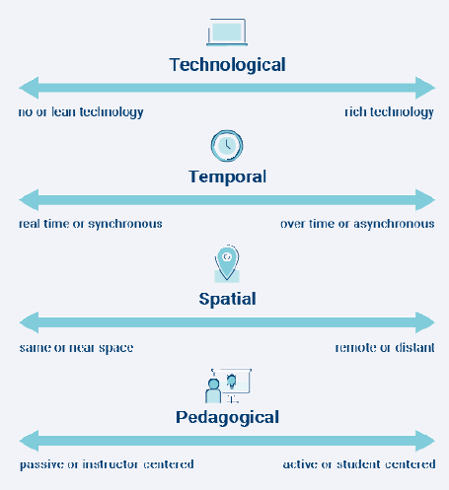
Figure 18 - The four dialecticals
Technological: refers to the leanness or richness of educational technology utilised by the lecturer to deliver course content. An example of lean technologies includes oral or text-based communication. Rich technologies include web conferencing technologies such as Zoom, Google Meet, and Microsoft Teams. (Joosten, Ph.D., and Weber, Ph.D. 2021)
Pedagogical: refers to relationships associated with learning. Active learning pedagogies positive impacts student success since technology is not the main objective but rather the delivery of the content by the lecturer. Hence, the integration of educational technologies into synchronous online classes must be driven by pedagogy. (Joosten, Ph.D., and Weber, Ph.D. 2021)
Temporal: refers to synchronous or asynchronous classes. Lecturers can incorporate group work for via live sessions or the lecturers can allow the students to work independently utilising online threaded discussions or quizzes to facilitate greater flexibility in the student learning activities. (Joosten, Ph.D., and Weber, Ph.D. 2021)
Spatial: refers to the provision of greater flexibility embedded in the course thereby allowing the student to learn independently or collaboratively regardless of time or location differences among classmates. (Joosten, Ph.D., and Weber, Ph.D. 2021)
With these four dialecticals identified, Dominica State College can take the following next steps:
- Establish a cohort of faculty members to examine the elements associated with hybrid learning and determine how these elements will be advantageous to the lecturers, instructional content, and student success.
- Have open and timed discussions with faculty members within the various programmes regarding best practices associated with various methods of hybrid instruction and incorporate the four dialecticals.
- Allow each department within the various faculties to design a hybrid program that will strengthen the college’s relationship with its stakeholders, thus achieving flexibility, new approaches to student learnings, and support.
- Strategic questions to be answered are: What are the problems or challenges our program faces? How can hybrid learning assist in solving these challenges? See Annex C – APPLICATION OF BALANCED SCORECARD FOR DSC for further guidance.
- Integrate and test best practices associated with active pedagogies that are student-centered.
- Carefully determine authentic learning experiences that will decrease faculty members load while improving student independent or group learnings.
- Incorporate professional and faculty development opportunities regarding hybrid learning.
- Create a lesson learned report at the end of each semester to document experiences learned. It’s important to document these lessons since they will aid in continuity and knowledge share across the faculties.
- Conduct research and experiment with various strategic designs within a variety of environments noting the results on the four dialecticals and active learning approaches that improved student outcomes.

9.2 Educational Technologies Competencies and Skills
The UNESCO Information and Communication Technology Competency Framework for Teachers (ICT CFT) version 3 (UNESCO 2019) encourages lecturers to integrate educational technologies into their synchronous and asynchronous classes. To support this integration, the framework has 18 educational technology-related competencies that is classed into three levels, each with six aspects. The levels are aligned to the lecturers integration approach. See Annex D – UNESCO ICT COMPETENCY FRAMEWORK FOR TEACHERS for further guidance.
The six aspects of a lecturer’s professional practice addressed are:
- Understanding educational technology in Education Policy.
- Curriculum and Assessment.
- Pedagogy.
- Application of Digital Skills.
- Organization and Administration
- Teacher Professional Learning.
The framework is organized into three successive levels of a lecturer’s development in making pedagogical use of educational technologies.
- Level 1 - Knowledge Acquisition
- Level 2 – Knowledge Deepening
- Level 3 - Knowledge Creation
Level 1 entails the lecturer acquiring knowledge about using technology and basic educational technologies competencies. This level demands that lecturers develop an awareness of the potential benefits of educational technologies in the classroom, within national policies and prioritizes being able to manage, organize the college’s educational technology investments and use technology to embark on lifelong learning and further professional development. See Annex D – UNESCO ICT COMPETENCY FRAMEWORK FOR TEACHERS Figure 23 - Level 1 Goals
Level 2 entails lecturers acquiring educational technology competencies that facilitates student-centred learning environments, collaboratively and cooperatively. Lecturers aligns policy directives with real action in the classroom, have the capacity to build technology-based plans to maintain the college’s educational technology assets, and forecast future needs. See Annex D – UNESCO ICT COMPETENCY FRAMEWORK FOR TEACHERS Figure 24 - Level 2 Goals
Level 3 entails lecturers acquiring competencies that encourage them to model good practice and set up learning environments that encourage students to create the kind of new knowledge required. See Annex D – UNESCO ICT COMPETENCY FRAMEWORK FOR TEACHERS Figure 25 - Level 3 Goals

Conclusion

This report presented an evaluation of technology integration among lecturers at DSC
- Literature review conducted to identify factor that influence adoption on educational technologies and survey was conducted among lecturers
- Analysis was done to determine these factors are apply to DSC
- Most lectures agreed that it ease fairly easy to transition to e-learning technologies, while a mere tiny minority claimed to have experienced some difficulties in doing so. Overall, it seemed lecturers were keen to ensure that students benefited from the learning experience and did not mind the effort the needed to make to do so.
- There is an overall high attendance to classes
- A high rate of mobile data use is surprising, but this is explained by the low proportion on high-speed fiber compared with more developed nations
- Most lecturers claimed not to suffer from online fatigue, which suggests that lecturers are coping well with the workload despite having to make some adjustments to adopt to online leaning.
- Efficacy scores indicated that easy to transition to online delivery are more than twice more likely to be effective in their delivery that those who disagreed and high efficacy scores were associated with high student attendance

Future Research Implications

Firstly, analysis methods should be piloted which was one of the downfalls of this research.
Secondly, the respondents participation was voluntary, hence, control measures regarding course design, delivery, programs, or strategies utilised by lecturers were not within the scope of this research. It must be noted however that the above-mentioned factors all contribute to positive student experience when integrating educational technologies into teaching and learning activities.
Lastly, this research was conducted over a three-month period which significantly limited the exploration time of the research.

References
Alkharang, M. M. 2014. "Factors that influence the adoption of e-learning : an empirical study in Kuwait." Semantic Scholar. https://www.semanticscholar.org/paper/Factors-that-influence-the-adoption-of-e-learning-%3A-Alkharang/48e07ba7055024d921e8316259bc21d5fab040c2.
Almaiah, Mohammed Amin, Ahmad Al-Khasawneh, and Ahmad Althunibat. 2020. "Exploring the critical challenges and factors influencing the E-learning system usage during COVID-19 pandemic." PubMed Central (National Center for Biotechnology Information) 1–20. Accessed December 8, 2021. doi:https://dx.doi.org/10.1007%2Fs10639-020-10219-y.
Arenas, E. . 2015. "Affordances of learning technologies in higher education multicultural environments." Electronic Journal of E-Learning 13 (4): 217 - 227. http://0-search.proquest.com.cataleg.uoc.edu/docview/1697674722?accountid=15299.
Bacher-Hicks, A., J. Goodman, and C. Mulhern. 2021. "Inequality in household adaptation to." Journal of Public Economics. Accessed December 8, 2021. doi:193:104345.
Bashir, Amreen, Shahreen Bashir, Karan Rana, Peter Lambert, and Ann Vernallis. 2021. "Post-COVID-19 Adaptations; the Shifts Towards Online Learning, Hybrid Course Delivery and the Implications for Biosciences Courses in the Higher Education Setting." Frontiers in Education. Accessed December 8, 2021. doi:https://doi.org/10.3389/feduc.2021.711619.
Brown , Cindy. 2012. "Application of the Balanced Scorecard in Higher Education: Opportunities and Challenges." Society for College and University Planning (SCUP). July - September. Accessed December 14, 2021. https://www.centenaryuniversity.edu/wp-content/uploads/2017/01/Brown-2012.pdf.
Demiris, G., M. J. Rantz, M. A Aud, and K. D Marek. 2004. "Older adults’ attitudes towards and perceptions of ‘smart home’technologies: a pilot study." Medical Informatics & The Internet in Medicine (29): 87-94. doi:10.1080/14639230410001684387.
Dissanayake, Anil. 2012. "What is IT-Business Alignment?" Pink Elephant. October. Accessed May 14, 2021. https://pinkelephant.com/uploadedfiles/content/resourcecenter/pinkpapers/what-is-it-business-alignment.pdf.
Dominica News Online. 2021. NTRC helps provide affordable internet access to students and their families. October 21. Accessed December 9, 2021. https://dominicanewsonline.com/news/homepage/news/media-telecommunications/ntrc-helps-provide-affordable-internet-access-to-students-and-their-families/.
Harris, J B, P Mishra, and M Koehler. 2009. "Teachers’ technological pedagogical content knowledge: Curriculum-based technology integration reframed." Journal of Research on Technology in Education 41 (4): 393–416.
Heinz, M, P Martin, J. A Margrett, and M Yearns. 2013. "Perceptions of technology among older adults." Journal of Gerontological Nursing (39): 42-51. doi:10.3928/00989134-20121204-04.
Index Mundi. 2021. Dominica Age structure. September 18. https://www.indexmundi.com/dominica/age_structure.html.
ITU. 2020. "Measuring digital development ICT price t rends 2020." International Telecommunications Union. Accessed December 13, 2021. https://www.itu.int/en/ITU-D/Statistics/Documents/publications/prices2020/ITU_ICTPriceTrends_2020.pdf.
Joosten, Ph.D.,, Tanya, and Nicole Weber, Ph.D. 2021. Planning for a Blended Future: A Research-Driven Guide for Educators. Every Learner Everywhere Network. Accessed December 14, 2021. https://www.everylearnereverywhere.org/resources/.
Li, Cathy, and Farah Lalani. 2020. The COVID-19 pandemic has changed education forever. This is how. April 29. Accessed December 8, 2021. https://www.weforum.org/agenda/2020/04/coronavirus-education-global-covid19-online-digital-learning/.
Lopez-Betancourt, Alicia, and Martha Leticia Garcia Rodriguez,. 2015. "An application of ASSURE model to solve contextual problems in virtual classroom." E-Learn: World Conference on E-Learning in Corporate, Government, Healthcare, and Higher Education. San Diego: Association for the Advancement of Computing in Education (AACE). 1332 - 1336. Accessed May 16, 2021. https://www.learntechlib.org/p/161834/.
Martínez-Alcalá, Claudia I., Alejandra Rosales-Lagarde, María de los Ángeles Alonso-Lavernia, José Á. Ramírez-Salvador, Brenda Jiménez-Rodríguez, Rosario M. Cepeda-Rebollar, José Sócrates López-Noguerola, María Leticia Bautista-Díaz, and Raúl Azael Agis-Juárez. 2018. "Digital Inclusion in Older Adults: A Comparison Between Face-to-Face and Blended Digital Literacy Workshops." Edited by Dina Di Giacomo. Frontiers in ICT. doi:https://doi.org/10.3389/fict.2018.00021.
McDonald, Dennis. 2019. Can Better Data Governance Improve Disaster Resilience? February 21. Accessed February 17, 2021. http://www.ddmcd.com/managing-technology/resilience.
McMellon, C. A, and L. G Schiffman. 2002. "Cybersenior empowerment: How some older individuals are taking control of their lives." The Journal of Applied Gerontology (21): 157-175. doi:10.1177/07364802021002002.
Mitzner, T. L. 2010. "Older adults talk technology: Technology usage and attitudes." Computers in Human Behavior 1710-1721. doi:10.1016/j.chb.2010.06.020.
Morrell, Roger W., Christopher B. Mayhorn, and Joan Bennett. 2000. "A Survey of World Wide Web Use in Middle-Aged and Older Adults." SAGE Journals 42 (2): 175-182. Accessed December 8, 2021. doi:https://doi.org/10.1518%2F001872000779656444.
Parolin, Zachary, and Emma Lee. 2021. "Large socio-economic, geographic and demographic disparities exist in exposure to school closures." Nature Human Behaviour 5 (4). Accessed December 8, 2021. doi:10.1038/s41562-021-01087-8.
Peterson, D A. 1980. Who are the educational gerontologists? 1st. Vol. 5. Educ Gerontol. doi:https://doi.org/10.1080/0360hyp800050105.
Prince, Rawle. 2003. "E-SIT: An Intelligent Tutoring System for Equation Solving." Amzi! Prolog + Logic Server. Accessed September 29, 2021. https://www.amzi.com/articles/e-sit.doc.
Rasi, Päivi, Hanna Vuojärvi, and Susanna Rivinen. n.d. "Promoting Media Literacy Among Older People: A Systematic Review." SAGE Journal 71 (1): 25. Accessed May 15, 2021. doi:https://doi.org/10.1177%2F0741713620923755.
Roslan, Nurhanis Syazni, and Ahmad Sukari Halim. 2021. "Enablers and Barriers to Online Learning among Medical Students during COVID-19 Pandemic: An Explanatory Mixed-Method Study." Edited by Jorge Martin Gutierrez. Sustainability. doi:https://doi.org/10.3390/su13116086.
Schmidt, Denise A., Evrim Baran, Ann D. Thompson, Punya Mishra, Matthew J. Koehler, and Tae S. Shin. 2009. "Technological Pedagogical Content Knowledge (TPACK): The Development and Validation of an Assessment Instrument for Preservice Teachers." Digital Library of Education Research and Information 42 (2): 123–149. Accessed December 14, 2021. https://files.eric.ed.gov/fulltext/EJ868626.pdf.
Shohel, M. M. C., and A. Kirkwood. 2012. "Using technology for enhancing teaching and learning in Bangladesh: challenges and consequences." Learning, Media and Technology 37 (4): 414 – 428.
SHULMAN, LEE S. 1986. "Those Who Understand: Knowledge Growth in Teaching." Education Researcher 15 (2): 4-14. Accessed December 8, 2021. doi:https://doi.org/10.3102%2F0013189X015002004.
Turk, H. S., and D. Akyuz. 2016. "The effects of using dynamic geometry on eighth grade." International Journal for 23 (3): 95-102. http://search.proquest.com.ezproxylocal.library.nova.edu/docview/1969007357?accountid=6579.
Turnbull, Darren, Ritesh Chugh, and Jo Luck. 2021. "Transitioning to E-Learning during the COVID-19 pandemic: How have Higher Education Institutions responded to the challenge?" National Center for Biotechnology Information 1–19. Accessed December 9, 2021. doi:https://dx.doi.org/10.1007%2Fs10639-021-10633-w.
UNESCO Institute for Statistics. 2012. "ICT IN EDUCATION IN LATIN AMERICA AND THE CARIBBEAN: A regional analysis of ICT integration and e-readiness." UNESCO. Accessed August 7, 2021. http://uis.unesco.org/sites/default/files/documents/ict-in-education-in-latin-america-and-the-caribbean-a-regional-analysis-of-ict-integration-and-e-readiness-en_0.pdf.
UNESCO & UNESCO Institute for Statistics. 2014. "INFORMATION AND COMMUNICATION TECHNOLOGY (ICT) IN EDUCATION IN ASIA: A comparative analysis of ICT integration and e-readiness in schools across Asia." UNESCO. Accessed August 5, 2021. doi:http://dx.doi.org/10.15220/978-92-9189-148-1-en.
—. 2015. "INFORMATION AND COMMUNICATION TECHNOLOGY (ICT) IN EDUCATION IN SUB-SAHARAN AFRICA: A comparative analysis of basic e-readiness in schools." UNESCO. August. Accessed August 6, 2021. doi:http://dx.doi.org/10.15220/978-92-9189-178-8-en.
UNESCO. 2019. UNESCO ICT Competency Framework for Teachers. April 4. Accessed August 18, 2021. https://unesdoc.unesco.org/ark:/48223/pf0000265721.
Velasquez, Andrea. 2010. Andrea Velasquez on Using the TPACK Framework for Evaluating Tech-Mediated Instruction. July 28. Accessed December 14, 2021. https://aea365.org/blog/andrea-velasquez-on-using-the-tpack-framework-for-evaluating-technology-mediated-instruction/.
World Bank. 2021. How to Age Well in Latin America. July 21. Accessed December 8, 2021. https://www.worldbank.org/en/news/feature/2021/07/21/c-mo-envejecer-bien-en-latinoam-rica.

Annex

Annex A – Tabular Details of Prime and Matured Respondents

Table 4- Sex and Age Range of Prime and Matured Respondents
Sex | Age Range | Frequency | Percent
Male | 40 – 49 | 1 | 9.1%
 | 50 – 59 | 2 | 18.2%
 | 60 – 69 | 1 | 9.1%
 | 70+ years | 1 | 9.1%
 |  | 5
Female
 | 40 – 49 | 3 | 27.3%
 | 50 – 59 | 2 | 18.2%
 | 60 – 69 | 1 | 9.1%
 | 70+ years | 0 | 0%
 |  | 6
Total |  | 11 | 100%

Table 5- Sex, Age Range and Qualification of Prime and Matured Respondents
Sex | Age Range | Bachelor's | Master's
Male
 | 40 - 49 | 0 | 1
 | 50 - 59 | 0 | 2
 | 60 - 69 | 0 | 1
 | 70+ years | 1 | 0
Female
 | 40 - 49 | 0 | 3
 | 50 - 59 | 0 | 2
 | 60 - 69 | 0 | 1
 | 70+ years | 0 | 0

Table 6- Sex breakdown of qualifications attained by Prime and Matured Respondents
Sex | Bachelor's | Master's
Male | 1 | 4
Female | 0 | 6
 | 1 | 10

Table 7- Prime and Matured Lecturers Faculty, Department and Years Employed
Faculty | Years Employed | Department | Frequency | Percent
FAS | 0 – 5 | Language Studies | 1 | 9.1%
 | 6 – 10 | Business | 1 | 9.1%
 | 11 – 15 | Computer Science | 1 | 9.1%
 | 16+ | Social Studies | 1 | 9.1%
 | 16+ | Mathematics | 2 | 18.2%
 | 16+ | Business | 1 | 9.1%
FOE |  |  |  | 9.1%
 | 0 – 5 | Science Education | 1 | 9.1%
 | 6 – 10 | Foundation | 1 | 9.1%
 | 16+ | Not Stated | 1 | 9.1%
General Studies |  |  |  | 9.1%
 | 11 – 15 | English | 1 | 9.1%

Table 8 - Faculty and Lecturers' integration
Faculty | Lecturer's Integration | Frequency | Percent
FAS | Daily | 3 | 27.27%
 | Weekly | 1 | 9.09%
 | Monthly | 3 | 27.27%
FOE | Daily | 2 | 18.18%
 | Weekly | 1 | 9.09%
 | Monthly | 0
General Studies | Daily | 0
 | Weekly | 1 | 9.09%
 | Monthly | 0

Annex B - Tabular Details of Students

Table 9- Breakdown of Students by Age range, faculty, and sex
Faculty | Sex | Age Range | Frequency
Continuing Studies Division | Female | 15 - 20 | 1
Continuing Studies Division | Female | 40 - 49 | 1
Continuing Studies Division | Male | 21 - 29 | 1
FAAT | Female | 15 - 20 | 21
FAAT | Female | 21 - 29 | 5
FAAT | Male | 15 - 20 | 26
FAAT | Male | 21 - 29 | 8
FAS | Female | 15 - 20 | 232
FAS | Female | 21 - 29 | 38
FAS | Female | 30 - 39 | 5
FAS | Female | 40 - 49 | 1
FAS | Male | 15 - 20 | 50
FAS | Male | 21 - 29 | 3
FAS | Male | 30 - 39 | 1
FAS | Male | 60+ | 1
FHS | Female | 15 - 20 | 17
FHS | Female | 21 - 29 | 12
FHS | Female | 30 - 39 | 8
FHS | Female | 50 - 59 | 1
FHS | Male | 15 - 20 | 3
FHS | Male | 21 - 29 | 1
FOE | Female | 15 - 20 | 2
FOE | Female | 21 - 29 | 5
FOE | Female | 30 - 39 | 4
FOE | Female | 40 - 49 | 1
FOE | Male | 50 - 59 | 1
General Studies | Female | 15 - 20 | 30
General Studies | Female | 21 - 29 | 5
General Studies | Female | 30 - 39 | 3
General Studies | Male | 15 - 20 | 4

Table 10- Distribution of Age Range and Sex of Students
Age Range | Sex | Frequency | Percent
15 - 20 | Female | 303 | 61.71%
15 - 20 | Male | 83 | 16.90%
21 - 29 | Female | 65 | 13.24%
21 - 29 | Male | 13 | 2.65%
30 - 39 | Female | 20 | 4.07%
30 - 39 | Male | 1 | 0.20%
40 - 49 | Female | 3 | 0.61%
50 - 59 | Female | 1 | 0.20%
50 - 59 | Male | 1 | 0.20%
60+ | Male | 1 | 0.20%

Table 11- Faculty breakdown by Sex
Faculty | Male | Female | Total | Percent
FAS | 55 | 276 | 331.00 | 67.41%
FAAT | 34 | 26 | 60.00 | 12.22%
FOE | 1 | 12 | 13.00 | 2.65%
FHS | 4 | 38 | 42.00 | 8.55%
Continuing Studies | 1 | 2 | 3.00 | 0.61%
General Studies | 4 | 38 | 42.00 | 8.55%

Annex C – APPLICATION OF BALANCED SCORECARD FOR DSC
Adopted from (Brown 2012)
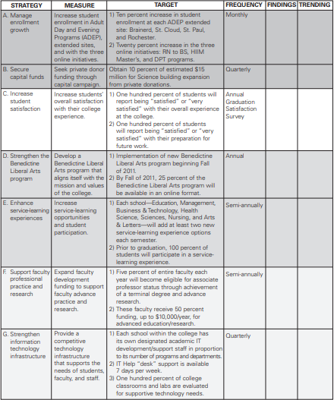
Figure 19 - Balanced Scorecard applied to Higher Education

Adopted from (Brown 2012)
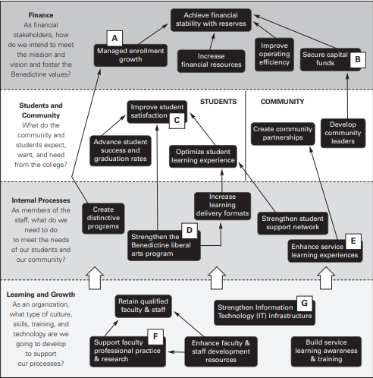
Figure 20 - Balanced Scorecard Strategy Map

Adopted from (Brown 2012)
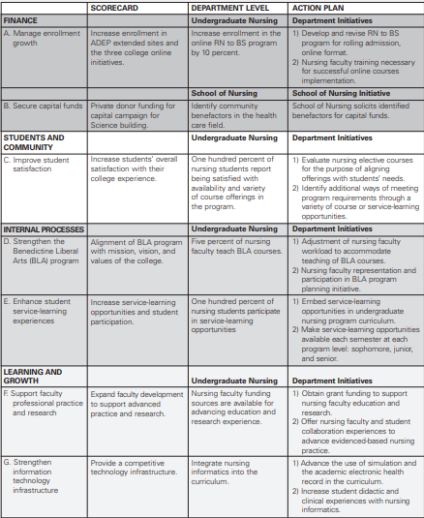
Figure 21 - Balanced Scorecard for Reporting

Annex D – UNESCO ICT COMPETENCY FRAMEWORK FOR TEACHERS

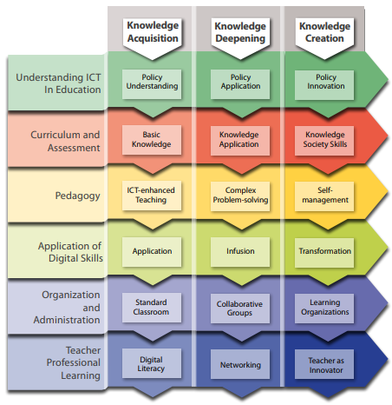
Figure 22 - The 18 competencies organized according to the six aspects of lecturers' and three levels
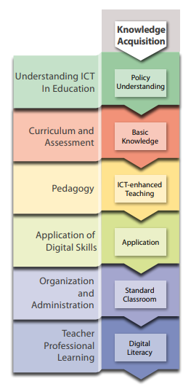
Figure 23 - Level 1 Goals
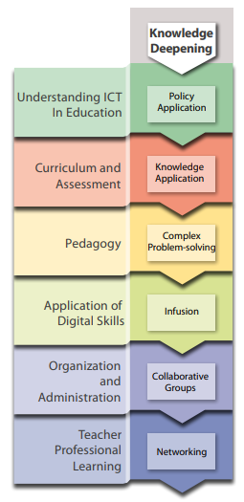
Figure 24 - Level 2 Goals
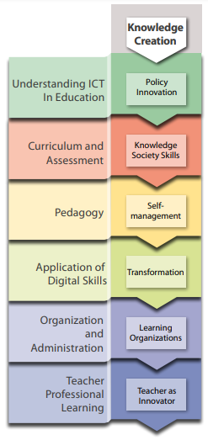
Figure 25 - Level 3 Goals

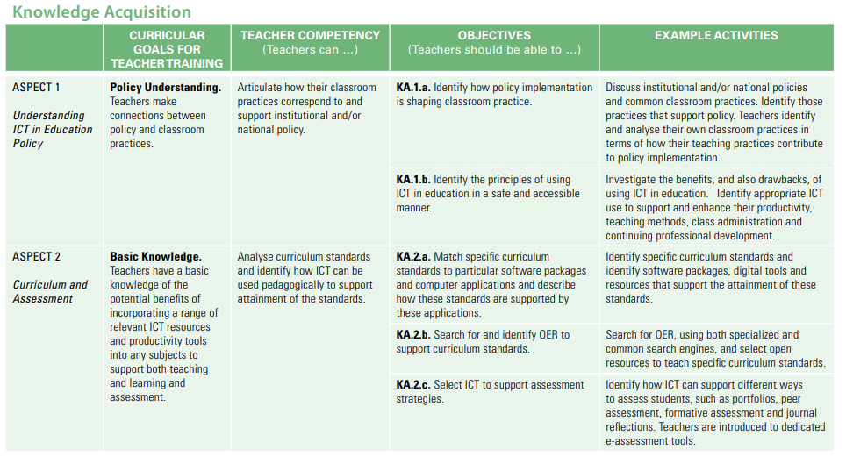
Figure 26 - Level 1 Competencies
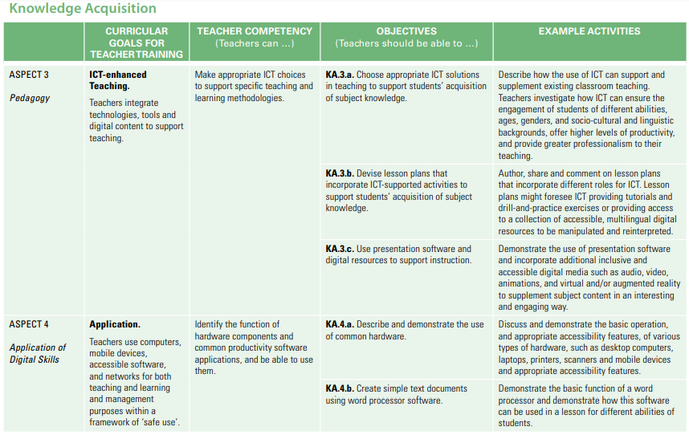
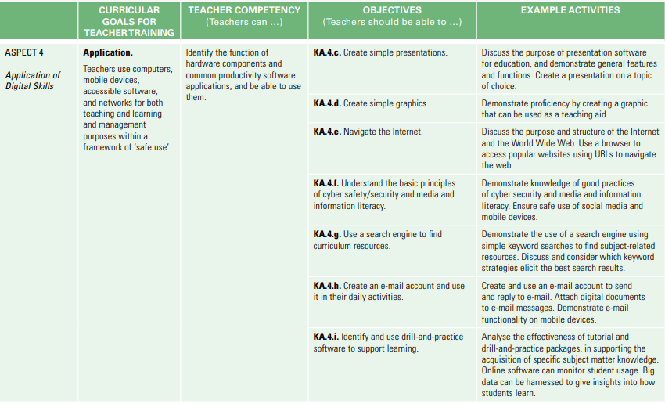
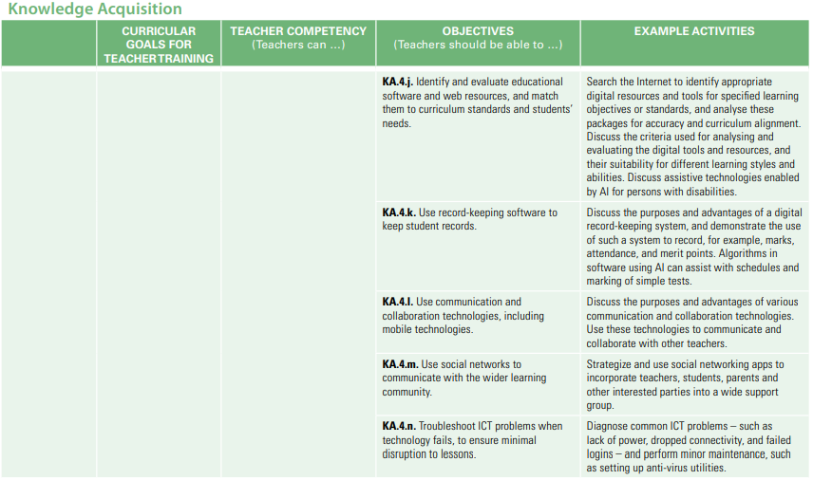
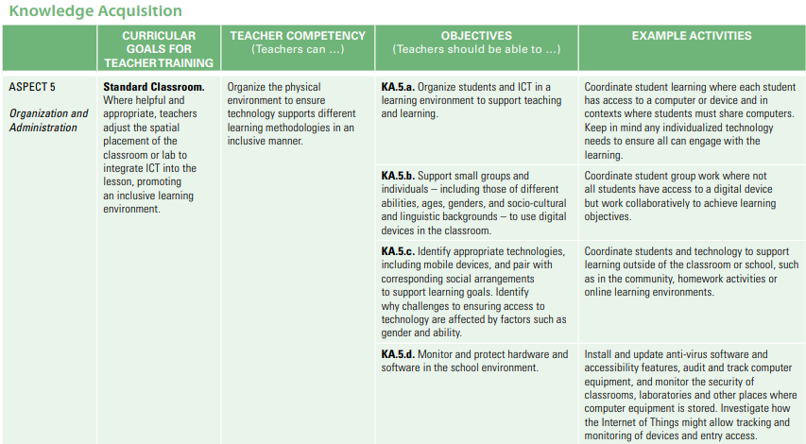
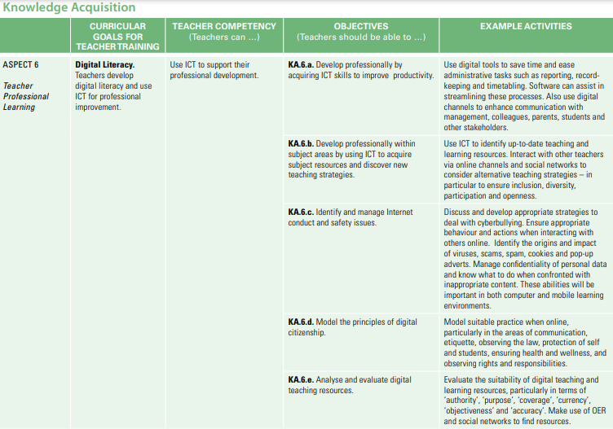

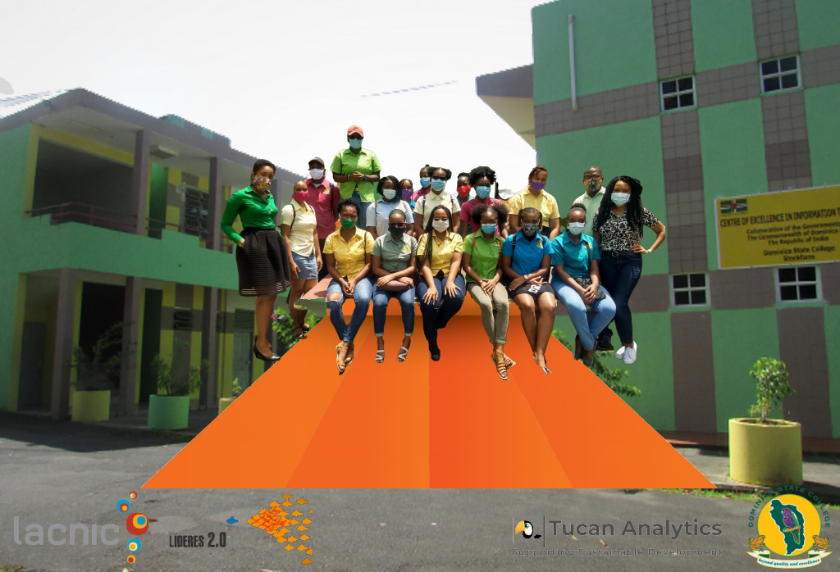

ASSURE is an instructional design model that has the goal of producing more effective teaching and learning. https://educationaltechnology.net/assure-instructional-design-model/
Kaizala is a messaging services from Microsoft: https://www.quexcel.com/knowledge-base/knowledge-base/microsoft-kaizala-versus-teams-and-the-licensing-options/
Systems thinking is an approach to integration that is based on the belief that the component parts of a system will act differently when isolated from the system’s environment or other parts of the system. https://learningforsustainability.net/systems-thinking/
Transforming our world: the 2030 Agenda for Sustainable Development: https://sdgs.un.org/2030agenda
https://www.worlddata.info/america/dominica/telecommunication.php
A common type of synchronous classroom includes a live-streamed lecture that students attend virtually, while Asynchronous classrooms often feature prerecorded lectures that students watch independently. https://thebestschools.org/resources/synchronous-vs-asynchronous-programs-courses/

